DIGITAL SIGNAL PROCESSING LABORATORY
EXPERIMENT NO. 4
Experiment Name: Design and Comparative Analysis of Butterworth, Chebyshev Type-I and Elliptic IIR Filters Using MATLAB
Date of Experiment: 12 October 2026

Objectives
- To design Butterworth, Chebyshev Type-I and Elliptic low-pass IIR filters using MATLAB.
- To compare the filter orders required to satisfy the given passband-ripple and stopband-attenuation specifications.
- To analyze and compare the magnitude and phase responses of the three filters.
- To measure passband ripple, stopband attenuation and transition bandwidth.

Program Code
clc;
clear;
close all;

%% Design and Comparative Analysis of IIR Filters

Fs = 1000;
Fp = 100;
Fst = 150;
Rp = 1;
Rs = 40;

Wp = Fp/(Fs/2);
Wst = Fst/(Fs/2);

%% 1. Butterworth Filter
[Nb, Wb] = buttord(Wp, Wst, Rp, Rs);
[bB, aB] = butter(Nb, Wb, 'low');

%% 2. Chebyshev Type-I Filter
[Nc, Wc] = cheb1ord(Wp, Wst, Rp, Rs);
[bC, aC] = cheby1(Nc, Rp, Wc, 'low');

%% 3. Elliptic Filter
[Ne, We] = ellipord(Wp, Wst, Rp, Rs);
[bE, aE] = ellip(Ne, Rp, Rs, We, 'low');

%% Display Filter Orders
fprintf('\nFILTER ORDER COMPARISON\n');
fprintf('Butterworth = %d\n', Nb);
fprintf('Chebyshev Type-I = %d\n', Nc);
fprintf('Elliptic = %d\n', Ne);

%% Display Coefficients
fprintf('\nBUTTERWORTH COEFFICIENTS\n');
disp('Numerator:');
disp(bB);
disp('Denominator:');
disp(aB);

fprintf('\nCHEBYSHEV TYPE-I COEFFICIENTS\n');
disp('Numerator:');
disp(bC);
disp('Denominator:');
disp(aC);

fprintf('\nELLIPTIC COEFFICIENTS\n');
disp('Numerator:');
disp(bE);
disp('Denominator:');
disp(aE);

%% Frequency Response
Nfft = 4096;
[HB, f] = freqz(bB, aB, Nfft, Fs);
[HC, ~] = freqz(bC, aC, Nfft, Fs);
[HE, ~] = freqz(bE, aE, Nfft, Fs);

MB = 20*log10(max(abs(HB), 1e-12));
MC = 20*log10(max(abs(HC), 1e-12));
ME = 20*log10(max(abs(HE), 1e-12));

%% Performance Analysis
P = f <= Fp;
S = f >= Fst;

RippleB = max(MB(P)) - min(MB(P));
RippleC = max(MC(P)) - min(MC(P));
RippleE = max(ME(P)) - min(ME(P));

StopB = -max(MB(S));
StopC = -max(MC(S));
StopE = -max(ME(S));

fprintf('\nPASSBAND RIPPLE (dB)\n');
fprintf('Butterworth = %.4f\n', RippleB);
fprintf('Chebyshev Type-I = %.4f\n', RippleC);
fprintf('Elliptic = %.4f\n', RippleE);

fprintf('\nSTOPBAND ATTENUATION (dB)\n');
fprintf('Butterworth = %.4f\n', StopB);
fprintf('Chebyshev Type-I = %.4f\n', StopC);
fprintf('Elliptic = %.4f\n', StopE);

fprintf('\nTRANSITION BANDWIDTH = %.2f Hz\n', Fst-Fp);

%% Magnitude Response Comparison
figure('Name', 'IIR Magnitude Response Comparison');
plot(f, MB, 'LineWidth', 1.5);
hold on;
plot(f, MC, 'LineWidth', 1.5);
plot(f, ME, 'LineWidth', 1.5);
xline(Fp, '--', 'Fp');
xline(Fst, '--', 'Fst');
yline(-Rp, ':', 'Passband limit');
yline(-Rs, ':', 'Stopband limit');
grid on;
xlabel('Frequency (Hz)');
ylabel('Magnitude (dB)');
title('Comparison of IIR Filter Magnitude Responses');
legend('Butterworth', 'Chebyshev Type-I', 'Elliptic', ...
'Location', 'southwest');
xlim([0 Fs/2]);
ylim([-80 5]);
hold off;

%% Phase Response Comparison
PhaseB = unwrap(angle(HB))*180/pi;
PhaseC = unwrap(angle(HC))*180/pi;
PhaseE = unwrap(angle(HE))*180/pi;

figure('Name', 'IIR Phase Response Comparison');
plot(f, PhaseB, 'LineWidth', 1.3);
hold on;
plot(f, PhaseC, 'LineWidth', 1.3);
plot(f, PhaseE, 'LineWidth', 1.3);
grid on;
xlabel('Frequency (Hz)');
ylabel('Phase (degrees)');
title('Comparison of IIR Filter Phase Responses');
legend('Butterworth', 'Chebyshev Type-I', 'Elliptic');
xlim([0 Fs/2]);
hold off;

%% Filter Order Comparison
figure('Name', 'IIR Filter Order Comparison');
orders = [Nb Nc Ne];
bar(orders);
set(gca, 'XTick', 1:3);
set(gca, 'XTickLabel', {'Butterworth', 'Chebyshev-I', 'Elliptic'});
ylabel('Filter Order');
xlabel('Filter Type');
title('Comparison of IIR Filter Orders');
grid on;

for k = 1:3
text(k, orders(k), sprintf('%d', orders(k)), ...
'HorizontalAlignment', 'center', ...
'VerticalAlignment', 'bottom');
end

MATLAB Output Screenshots
Figure 1: Comparison of IIR filter magnitude responses, phase responses and filter orders.
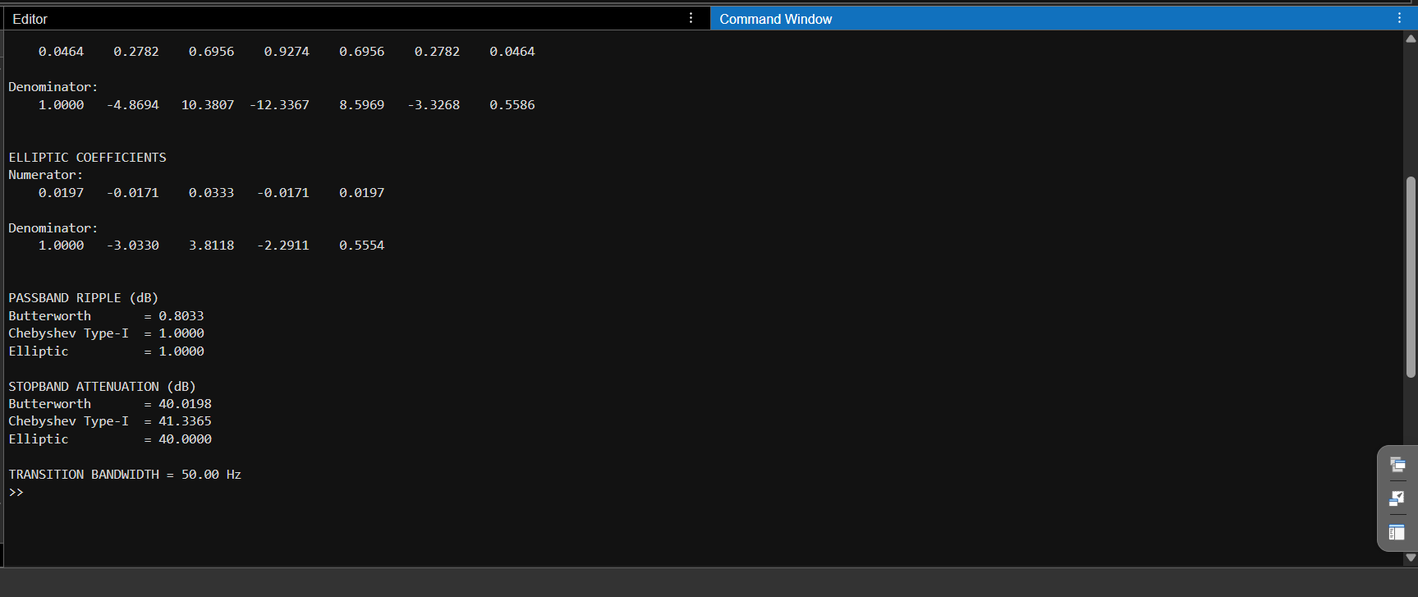
Figure 2: MATLAB Command Window showing the calculated filter coefficients and performance measurements.
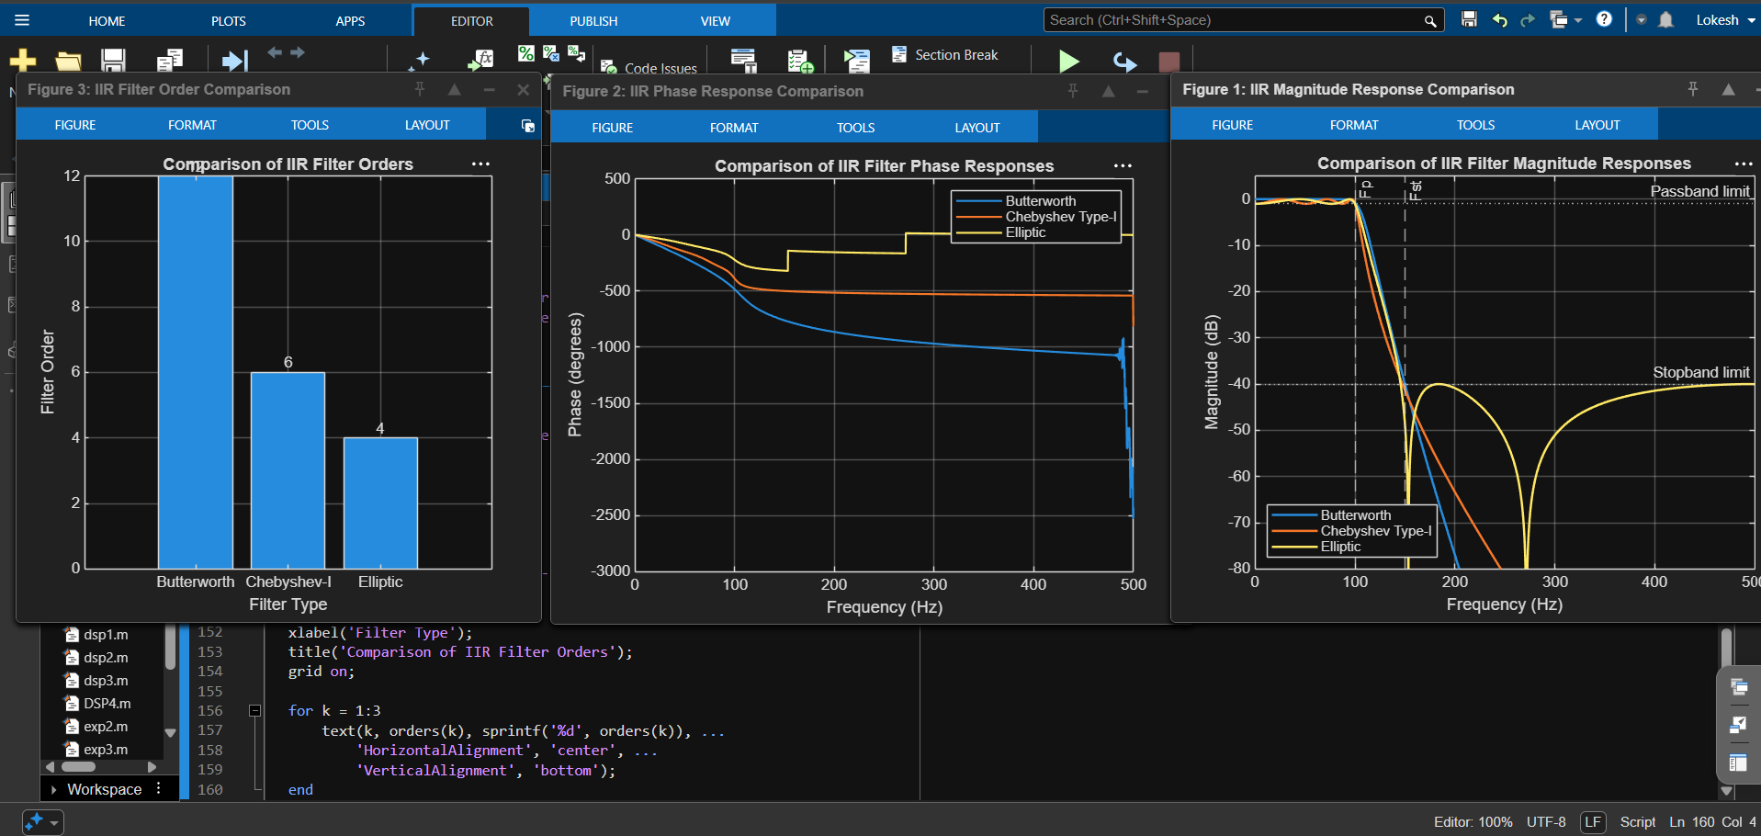

Done by
Lokesh A
Register Number: 192512293
B.E. Electronics and Communication Engineering (ECE)

